SuperStars Summer Holiday Courses
Blue Coat CE Primary School
Week 3: Mon 5th Aug - Fri 9th Aug & Week 5: Mon 19th Aug - Fri 23rd Aug

Free SuperStars summer hat on all bookings made before Friday 5th July

Looking for an 'Outstanding'multisports holiday course this summerholidays? We canHelp.
It's OK, you can breathe a sigh of relief, because this summer we've teamed up
with Blue Coat CE Primary School to run our multisports holiday course here at your school. We offer more than 40 sports and games, suitable for children of all ages and abilities.
We'll encourage your child to try something new and be the best they can be. Because we want them to leave us with new confidence and feeling proud of what they've achieved. I

We want to be a hit with you too
With lots of parents, we already are. In fact, 96.7% of those we asked said theyʼd recommend our courses to a friend. And we get lots of positive feedback, like this from a parent in Cardiff:
“From my child's point of view SuperStars is exciting, fun and enjoyable. From my point of view, it' s safe, well-organised and affordable. We' r e both very happy.”
We run all our holiday courses on school sites. We do this so the children are in a familiar environment, often with their friends. A lot of our staff provide specialist support in schools during term time, so theres every chance you and your child will know the course leader too.
Using school sites also helps your mornings run smoothly as you can keep to your normal routine. And it keeps the cost of our courses down, as we're not paying high commercial rents. Savings we pass straight on to you.

SuperStars. Good for you, a blast for your kids
We help children get active, have fun and learn new skills, in a place where they feel safe and secure. And, because we know juggling work and family is sometimes hard, we make the holidays easier for you too. Turn the page now and find out how to book.
Yours,

Curtis Ivin, Holiday Course Manager
Activities on offer include: World Cup Football - Dance - Tag Rugby - Netball - Capture the flag -Basketball - Athletics Cricket - Dodgeball - Ultimate Frisbee - Hockey and many more! Visit www.super-stars.org.uk/summer2019courses/

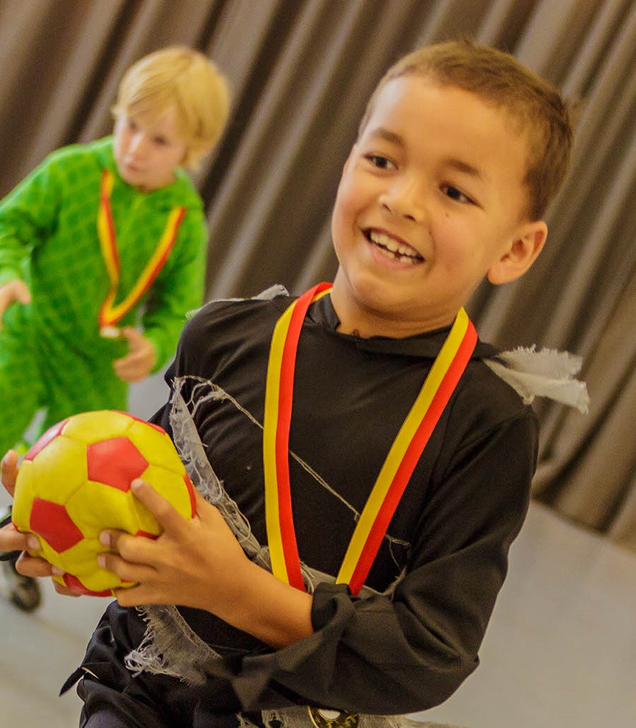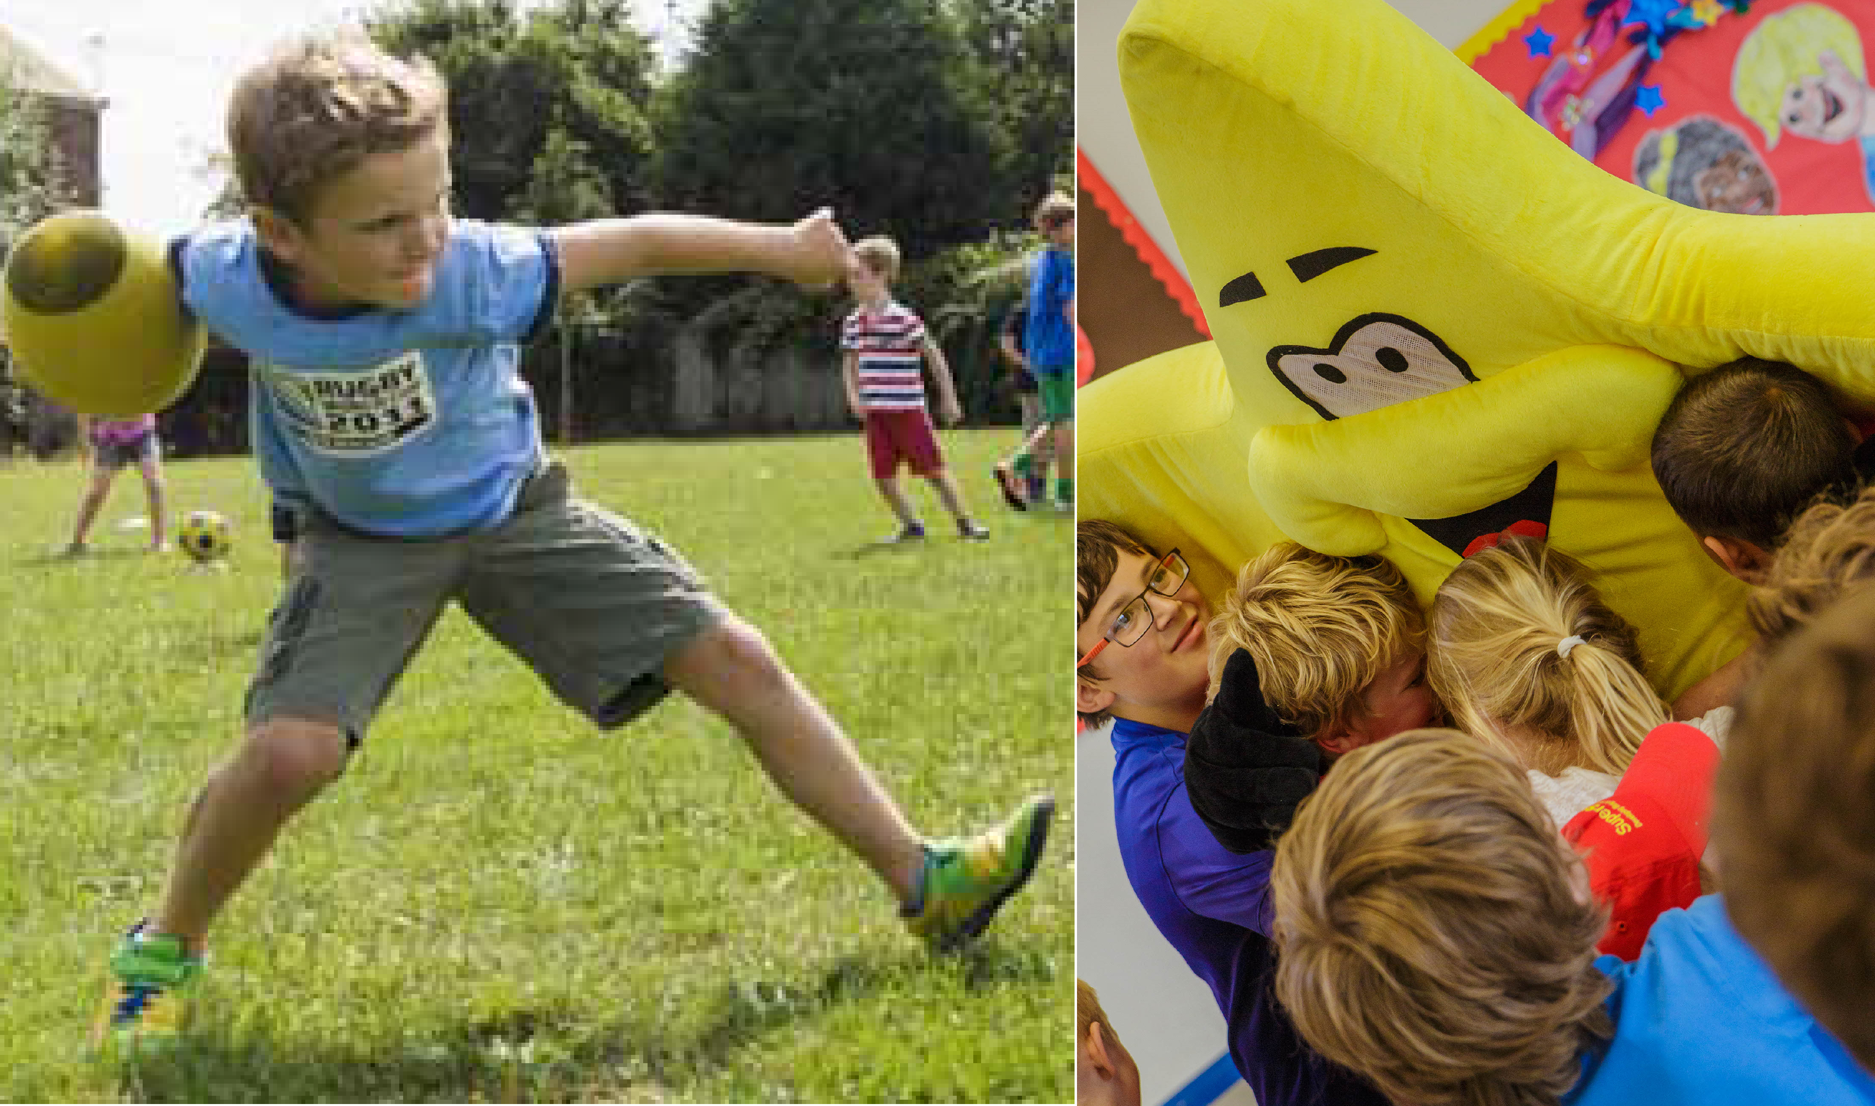Two easy ways to book
Online at www.super-stars.org.uk/holiday-courses Call us on 0345 241 3682
1
2

Spaces are limited! And can go fast!
Book early to secure yours (plus get your FREE SuperStars summer hat!) Course fees (from just £10.50 per day when booking for the week!)
Course Duration | Mini Stars (Age 4) 8.45am – 1.00pm | SuperStars (Age 5+) 8.45am – 3.30pm
1 Day | £16.50 | £21.50
2 Days | £33.00 | £43.00
3 Days with discount | £49.50 - £42.50 (Saving £7) | £64.50 - £57.50 (Saving £7)
4 Days with discount | £66.00 - £52.50 (Saving £13) | £86.00 - £72.50 (Saving £13)
5 Days (for the price of 4) | £82.50 - £52.50 (Saving £30) £107.50 - £72.50 (Saving £35)

Why choose SuperStars this summer?
- We have been running since 2005, so we have a wealth of experience
- Awarded CB Childcare 'Outstanding' accreditation (Summer 2018 Inspection)
- 8,000 children attended our courses in 2018, giving us the 'double thumbs up'
- 96.7% of parents would recommend us to friends and family members. (2018 Business Review Survey, 287 parent responses)
- We run smaller courses, usually for around 20 - 30 children, so you can be sure we'll get to know your child and will give them individual attention
- All our coaches have current, enhanced DBS checks. And all our courses are approved and regulated by an external child safety provider
- All our coaches are qualified, enthusiastic and committed to helping children develop

We need to make sure we have the correct ratio of staff to children for all our courses. If you book late or on the day, we may need to add extra cover at short notice. If we have no staff available we may not be able to accept your child on the course. Days must be booked within the same week for the 5th day discount to apply. Terms and conditions apply.

T 0345 241 3682
E admin@super-stars.org.uk W super-stars.org.uk

@SuperStars_UK SuperStarsHolidayCourse

